1. Use ps command with options to display all active process running on the system

$ ps -ef # list all active process in a full format list

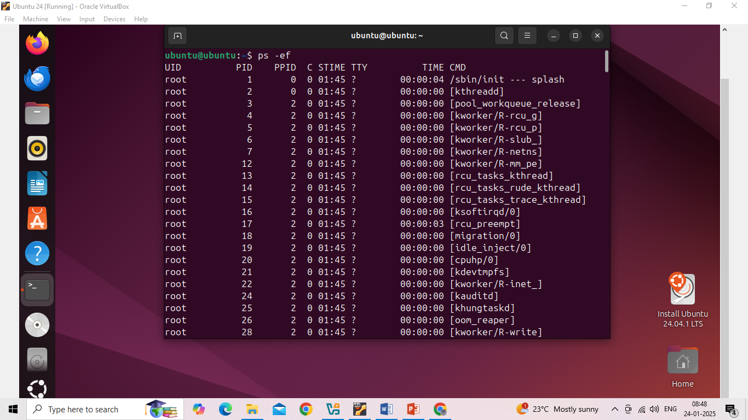

$ ps -ux #used to monitor the user owned process in detail manner

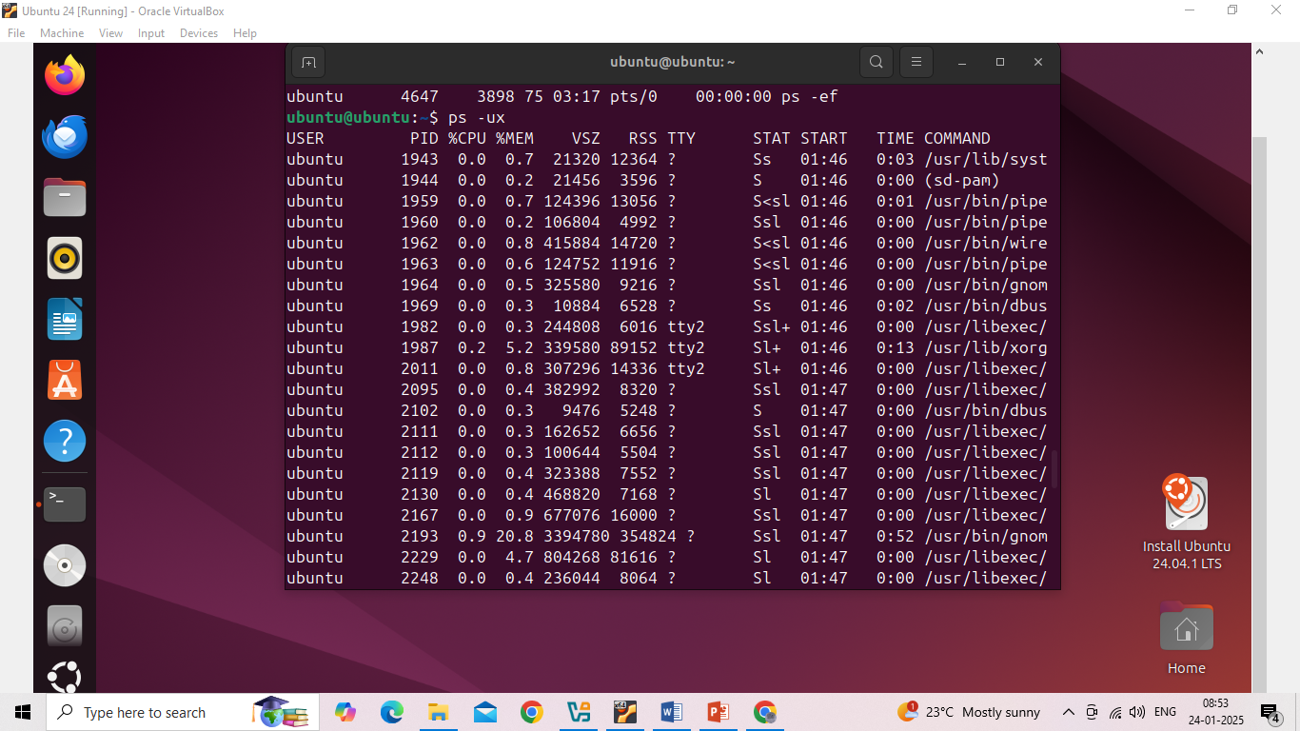

$ ps -G root #Process selected by group name

